Vector Projection

The formula for projecting vectoronto vectoris as follows:.

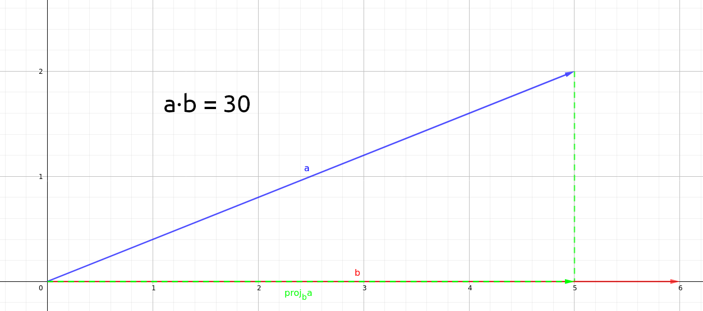
But what does it really mean? We can break the formula down into simpler terms by rewriting it as.

To find the projection ofonto, we need the length and direction of the projected vector.

Firstly, let’s find the length of.gives us the length ofmultiplied by the length of. To get the length of, we divideby the length ofwhich gives us. And there we have it, the length ofhas been found.

Next, we want to find the direction of the vector. Sinceis projected onto, we know thatis in the same direction as. And since we have the length of, we just need to multiply it with a unit vector in the direction of. To normalise, we simply divideby its length. This gives us. And thus, we have found the direction of .

Finally, multiply the direction and length oftogether, and we have the formula.

Representing a point as the sum of its projection onto the axes.

For any arbitrary orthogonal axes, a point can be represented as the sum of its projection into the axes.

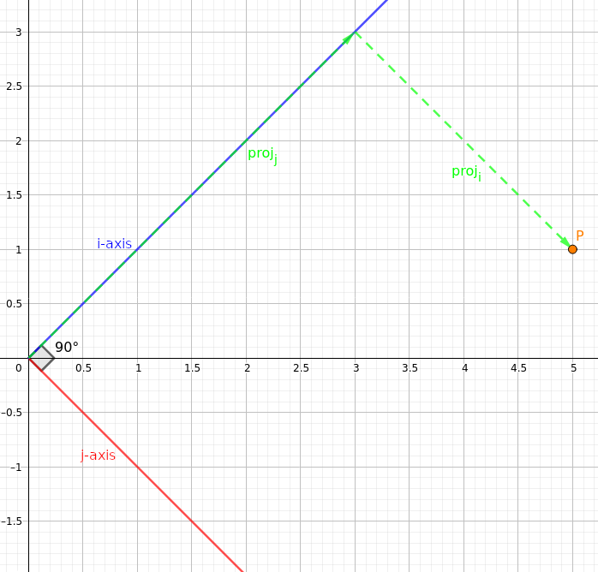
As can be seen in the figure above, if we take any arbitrary orthogonal axesandto be our axes, we can represent pointas the sum of its projection onto axesand. Similarly in 3D, as long as all 3 axes are orthogonal, we can represent pointas the sum of its projection onto axesand.

However, the above is not true for non-orthogonal axes, where a point cannot be represented as the sum of its projection into the axes.

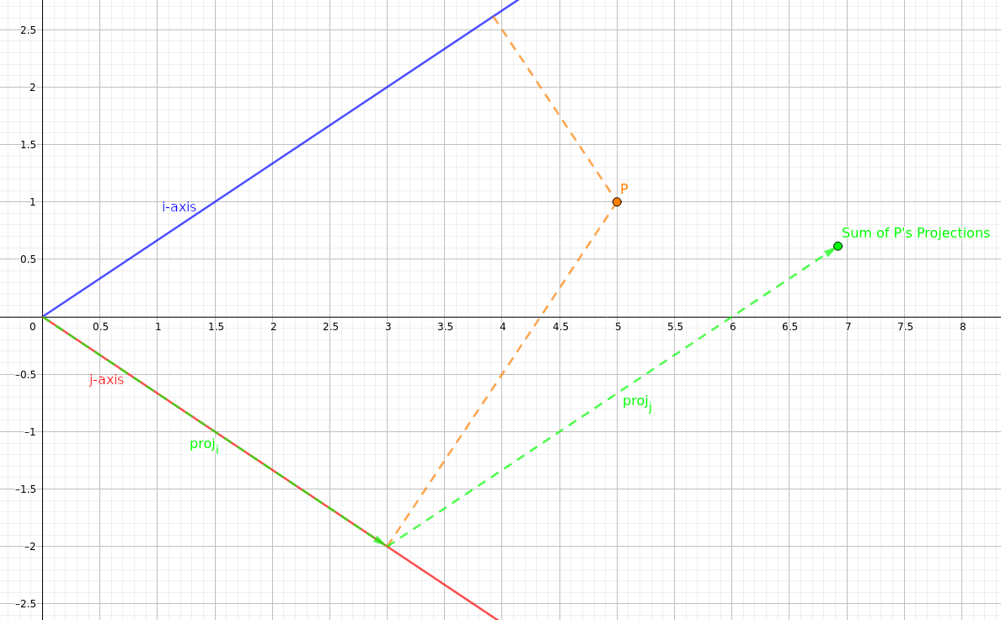
As can be seen in the figure, pointcannot be represented as the sum of its projection onto axesand. Similarly in 3D, as long as 2 of the axes are not orthogonal, pointcannot be represented as the sum of its projection onto axesand.

